**Front End Engineering-II**

Project Report

Semester-IV (Batch-2022)

**COUNTDOWN TIMER**



**Supervised By: Submitted By:**

Dr. Raveesh Samkaria Saksham

2210990761

G-31

**Department of Computer Science and Engineering**

**Chitkara University Institute of Engineering &Technology,**

**Chitkara University, Punjab**

# ABSTRACT

A countdown timer is an ideal way to set targets to complete tasks example- keep a reminder for the oven etc. For large-scale applications such as industries, complex timers are used, which are custom-designed for various purposes such as triggering or flipping a switch after a delay of set time. We might have noticed a screensaver appearing on the desktop when left idle for sometime. This happens because of the timer which calculates our idle time. Similarly ,automatic logging out of websites, OTP expiration, captcha expiration are all based on a timer which nullifies these password after the time period expires.

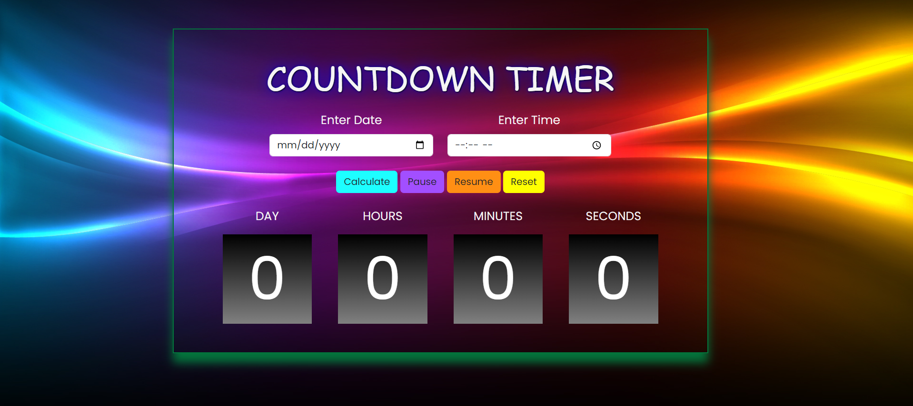

# INDEX

|  |  |  |
| --- | --- | --- |
| **S.No.** | **Title** | **Page Number(s)** |
| 1 | Introduction | 4 ,5 |
| 2 | Problem Statement | 5 |
| 3 | Software Requirements | 5,6 |
| 4 | Proposed Design | 7-8 |
| 5 | File structure | 8-11 |
| 6 | Results | 12 |
| 7 | References | 13 |

# Introduction

The countdown timer lets you increase your recipients’ attention and conversion rates by counting down the time until your offer runs out. The countdown timer displays the number of days, minutes, hours and seconds currently remaining on an offer, regardless of when a recipient opens your newsletter. The countdown timer is dynamic, agile and flexible. You can customize the timer and the graphic layout.

**1.1Background:**

Countdown timers have become a ubiquitous feature in modern digital interfaces, ranging from simple websites to complex applications. They serve the purpose of displaying the time remaining until a specified event, deadline, or action. The concept of countdown timers is derived from traditional timekeeping methods, where devices like hourglasses or clocks were used to measure time intervals.

**1.2Objectives:**

1. Examine Design Principles: Analyze the design principles behind effective countdown timers, including visual design, user interaction, and accessibility considerations.

2. Discuss Use Cases: Explore the various use cases of countdown timers in different applications and industries, highlighting their impact on user engagement and experience.

3. Evaluate Implementation Techniques: Discuss the technical aspects of implementing countdown timers, including the use of web technologies such as HTML, CSS, and JavaScript, as well as mobile development frameworks.

4. Provide Recommendations: Offer recommendations for designing and implementing countdown timers based on best practices and emerging trends in user interface design.

**1.3 Significance:**

The significance of countdown timers lies in their ability to create a sense of urgency and anticipation among users. They are commonly used in various scenarios, such as:

1. Event Promotion: Countdown timers are often used to build anticipation for upcoming events, product launches, or sales, encouraging users to stay engaged and return at the designated time.

2. Deadline Management: In productivity tools and project management applications, countdown timers help users track deadlines and stay focused on completing tasks within a specified timeframe.

3. User Engagement: Websites and applications use countdown timers to engage users, for example, by offering limited-time discounts or promotions, prompting users to take action before the timer expires.

4. Time Management: For personal use, countdown timers can be used to manage time effectively, such as for cooking, exercising, or managing study sessions.

# Problem Statement

Countdown timers are integral features in digital interfaces, serving various purposes such as event promotion, deadline management, and user engagement. However, designing and implementing countdown timers effectively can pose several challenges. The problem statement addresses these challenges and aims to find solutions to ensure optimal performance and user experience.

# Software Requirements

**I. Integrated Development Environment (IDE):**

Visual Studio Code (VS Code) will be utilized as the primary code editor and project management tool for its robust features, extensive extension ecosystem, and efficient workflow.

1. **Technology Requirements:** 
   * HTML5 (Hypertext Markup Language) will be employed for structuring the web application and creating the necessary elements for the clock components and user interface.
   * CSS3 (Cascading Style Sheets) will be used for styling the application, ensuring a visually appealing and coherent design across different components and screen sizes.
   * JavaScript (ES6+) will be the programming language of choice for implementing interactive features, dynamic updates, time calculations, and handling user interactions within the application.
2. **Utility-first CSS Framework:**

Bootstrap, a popular front-end framework, will be utilized to simplify the styling process and create a modern, responsive design with minimal effort. Bootstrap's pre-built components and grid system will help achieve a consistent and professional look across different devices and screen sizes.

**IV. Version Control and Collaboration:**

Git, a distributed version control system, will be utilized for tracking changes in the project codebase, enabling efficient collaboration, and facilitating code reviews and merges. The project repository will be hosted on GitHub, a popular platform for code hosting, collaboration, and issue tracking.

**V. Browser Compatibility and Performance:**

The application will be developed with a focus on cross-browser compatibility, ensuring it functions correctly and consistently across the latest versions of popular web browsers. Performance optimization techniques will be implemented to ensure smooth and efficient rendering, minimizing resource consumption and providing an optimal user experience.

# Proposed Design

**User Interface:**

* The application will feature a responsive and visually appealing layout using Bootstrap 5, ensuring a consistent experience across various devices and screen sizes.
* A card-based design will be employed to organize the different components of the application, such as the countdown timer in an intuitive and user-friendly manner.
* User can enter date and time ,and the countdown will update dynamically until the specified time is reached.

**Development Technologies:**

* HTML5 semantic elements will be utilized for structuring the application, ensuring proper semantics and accessibility.
* CSS will be responsible for styling the application, creating a visually appealing and cohesive design.
* JavaScript will be used for implementing dynamic UI updates, handling user interactions, and managing the clock logic and time calculations.

**User Experience:**

* Real-time feedback and interactive elements, such as smooth animations and transitions, will be implemented to create an engaging and responsive user interface.
* Cross-browser compatibility will be a priority, ensuring the application functions consistently across the latest versions of popular web browsers.
* Responsiveness will be a key focus, with the application designed to adapt seamlessly to different devices and screen sizes, providing an optimal user experience on both desktop and tablets platforms.

**Testing and Quality Assurance:**

* Comprehensive testing, including manual and unit tests, will be conducted to ensure the application's functionality and user interface consistency.

**Documentation and Deployment:**

* Detailed documentation, including installation instructions, usage guidelines, and relevant information for developers and users, will be provided.
* The application will be deployed on a web server with a domain, ensuring accessibility and ease of use for end-users.
  1. **File Structure**

Establishing a meticulous organization of files and folders to uphold uniform file paths and a clutter-free arrangement.

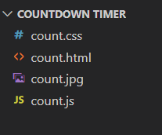

* 1. **HTML Code Structure**

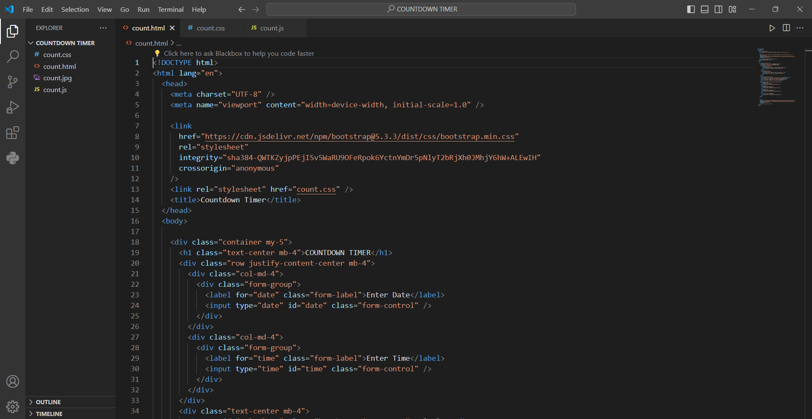

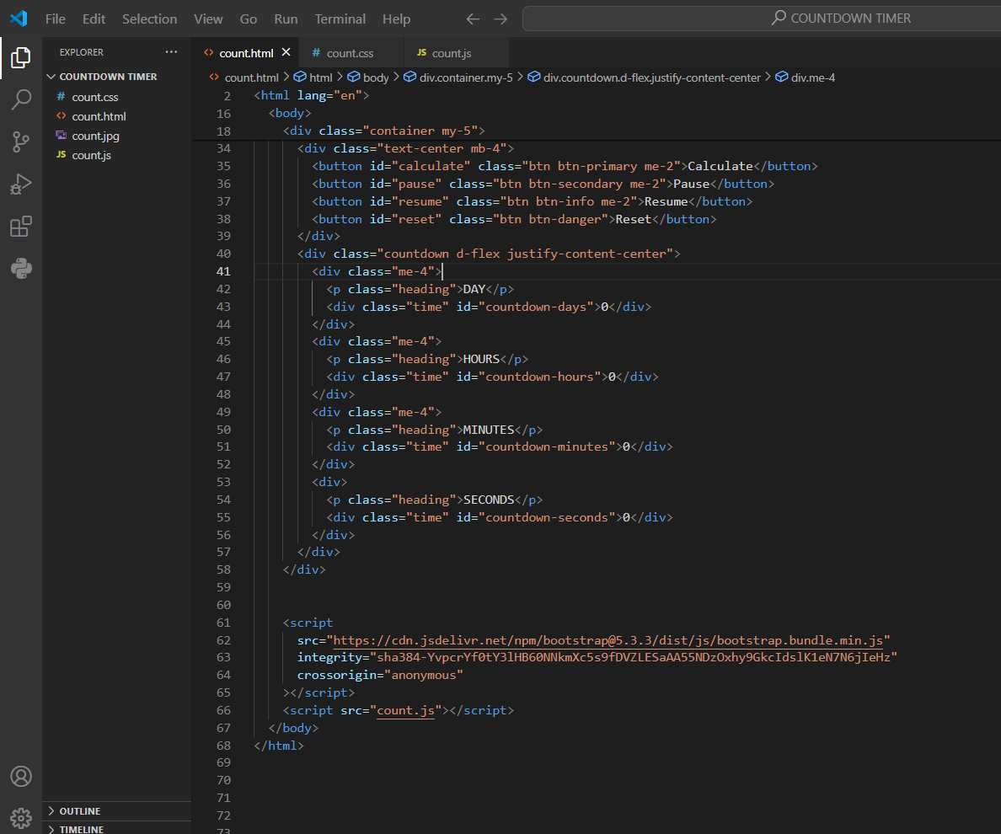

**4.3CSS Code Structure**

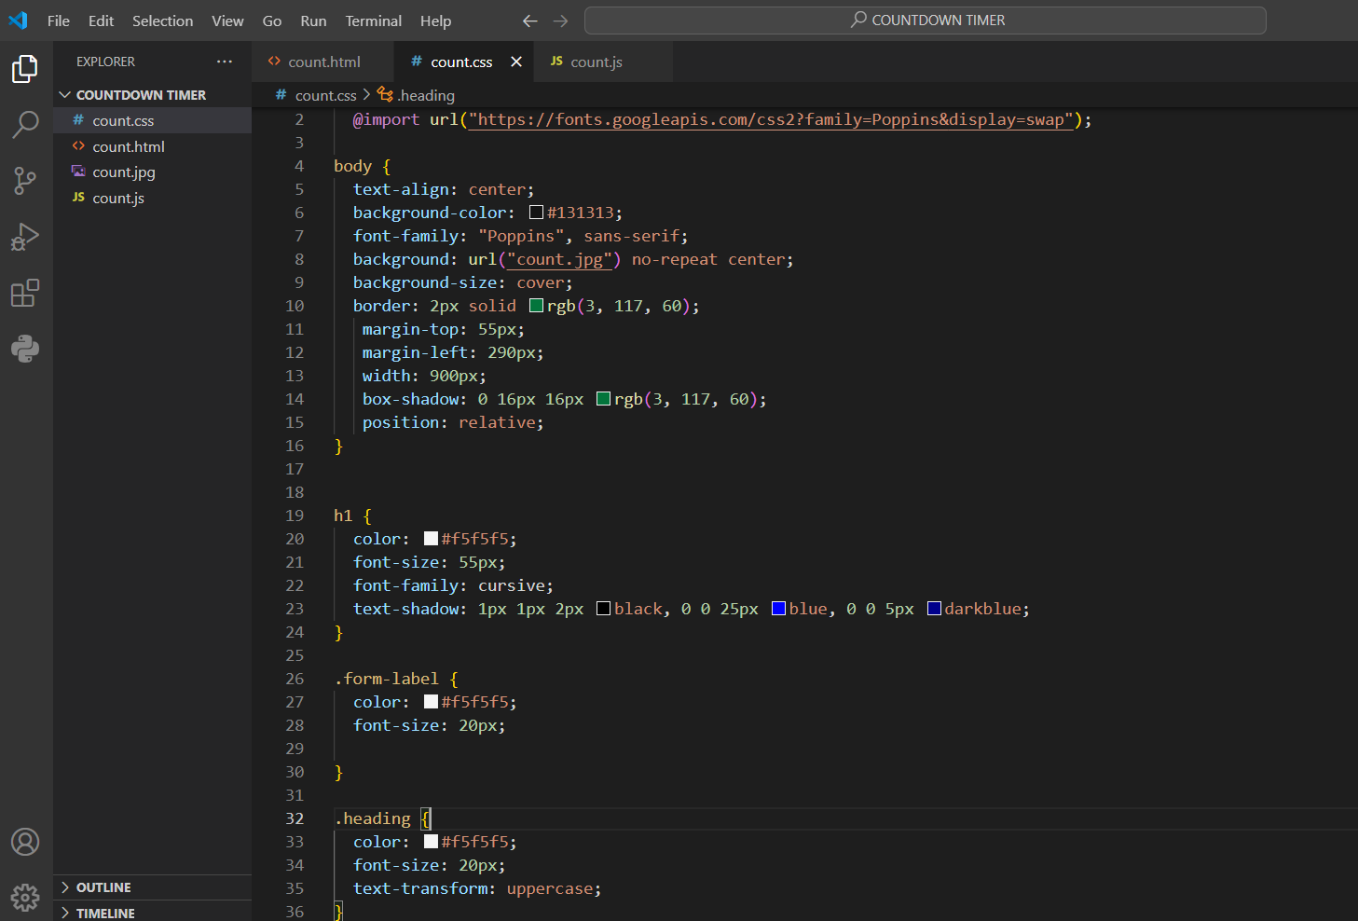

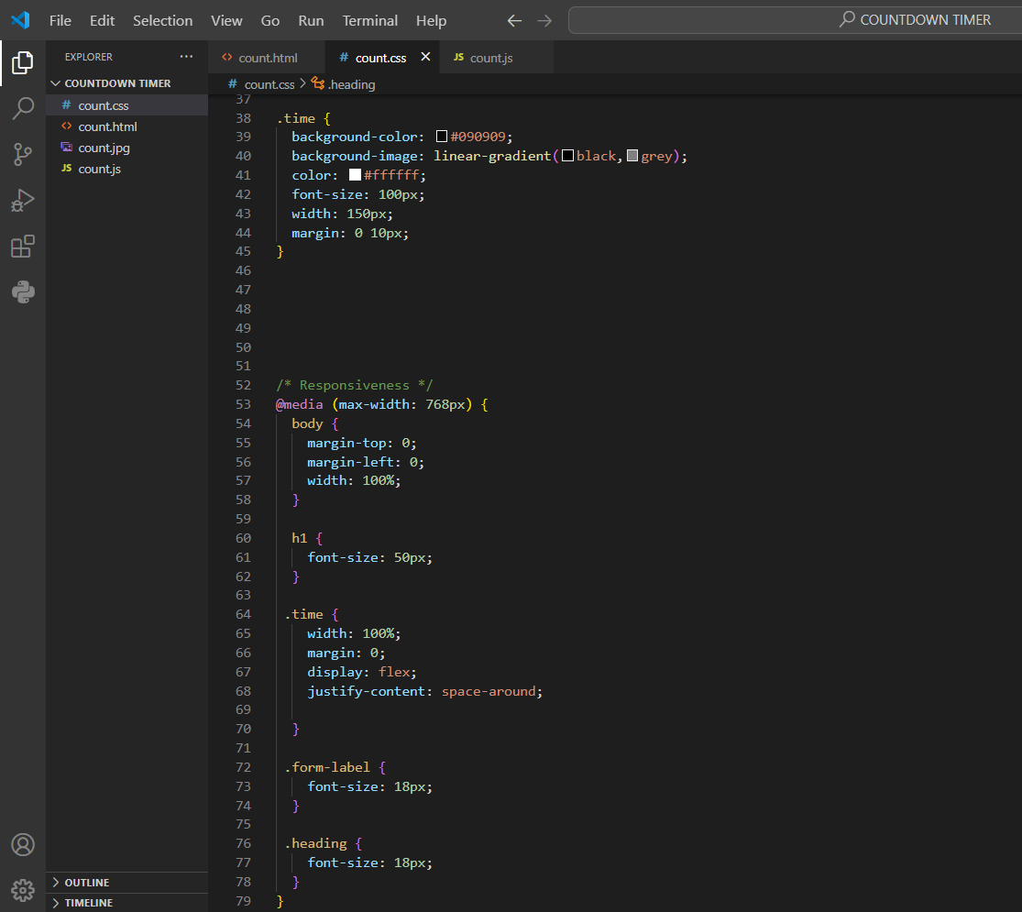

* 1. **Javascript Code Structure**

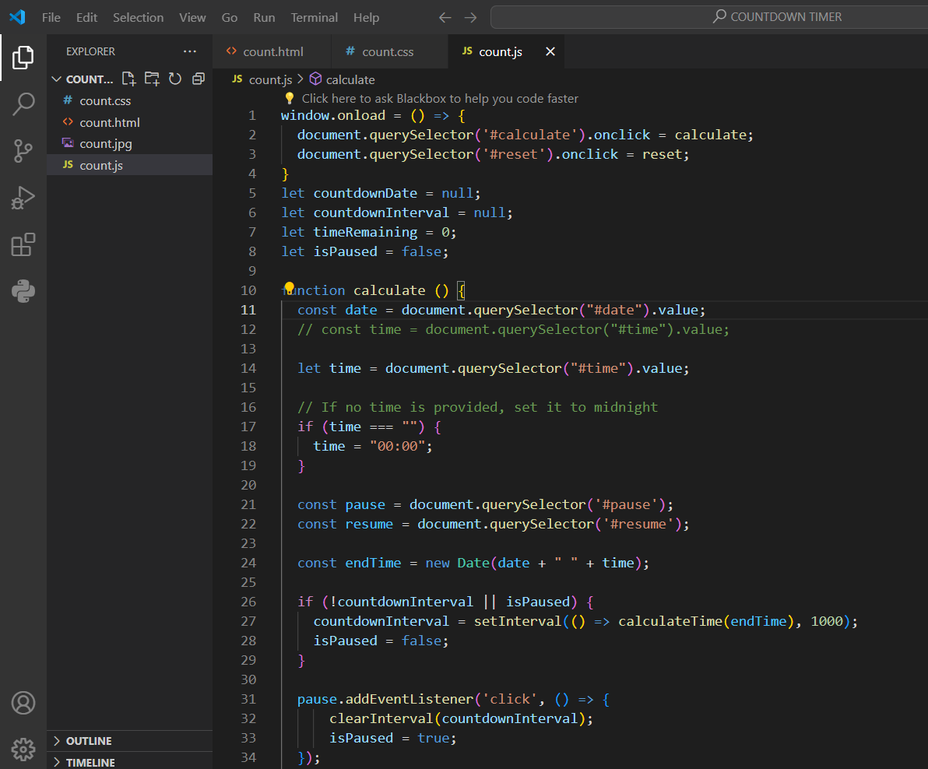

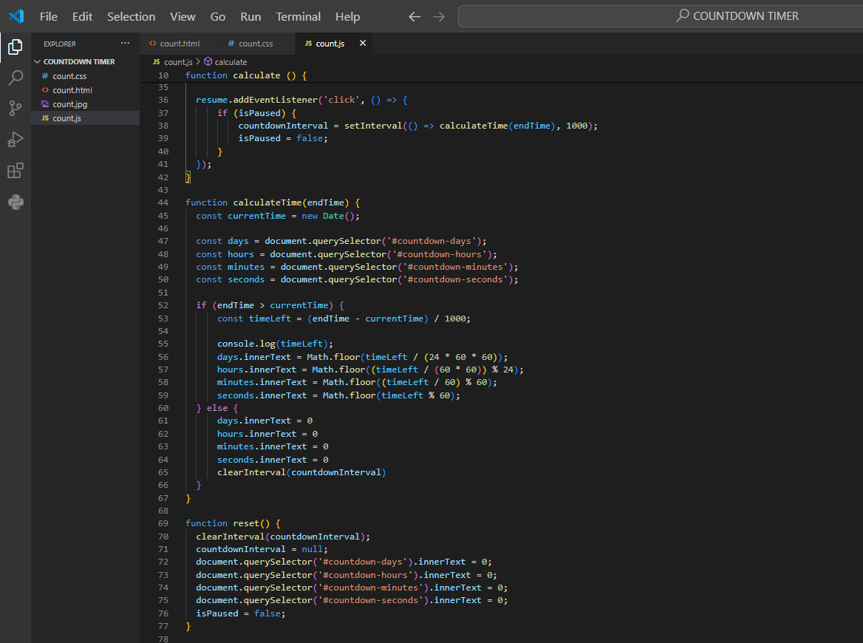

# Results

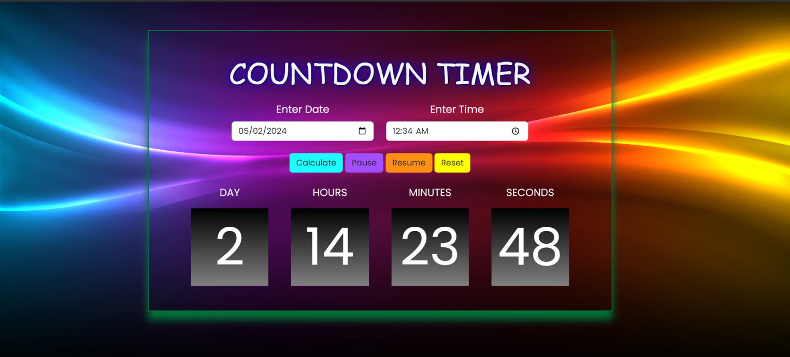

With date and time

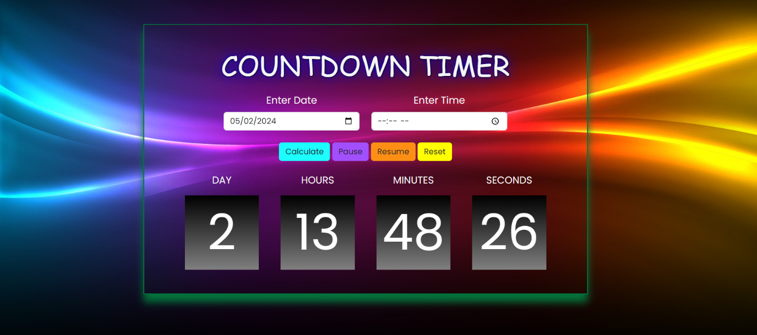

With date only

# References

* **Mozilla Developer Network (MDN) - HTML, CSS, JS Documentation:**

Website: https://developer.mozilla.org/

Description: MDN offers comprehensive documentation on HTML, CSS, and JavaScript, covering everything from basic syntax to advanced concepts

* **W3Schools - HTML, CSS, JavaScript Tutorials:**

Website: https://www.w3schools.com/

Description: W3Schools provides beginner-friendly tutorials and references for HTML, CSS, and JavaScript, along with interactive code examples.

* **Bootstrap Documentation:**

Website: https://getbootstrap.com/

Description: The official Bootstrap documentation provides detailed guidance on usinTailwind CSS for building modern and responsive web interfaces. It includes utility classes, customization options, and best practices.